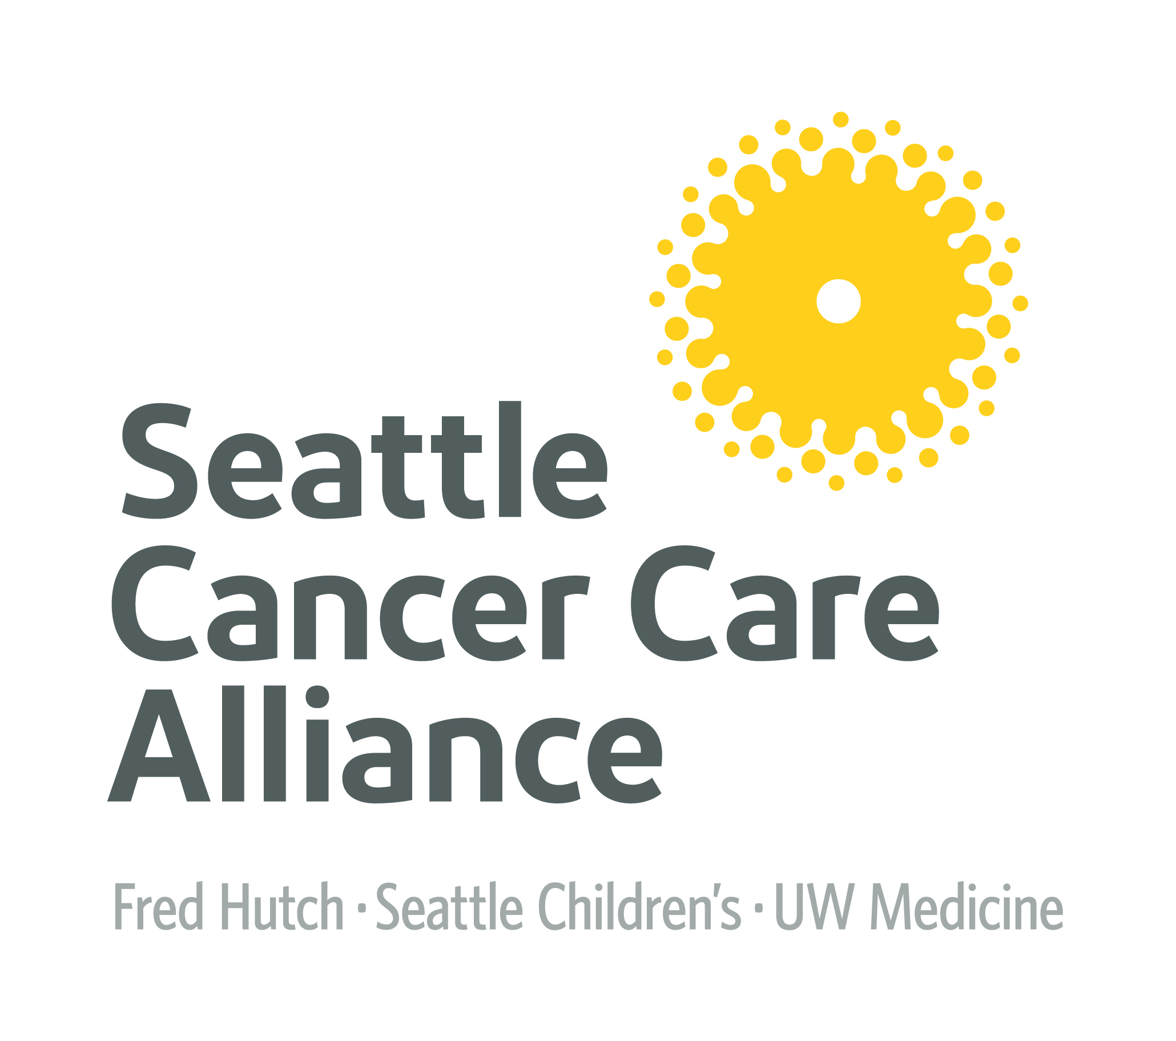 | Rosemary Ford Future of Oncology Nursing Scholarship  University RN Student
Purpose:
To support a BSN nursing student of junior standing enrolled at each university; Seattle Pacific University, Seattle University and the University of Washington (UW) School of Nursing, Seattle, who is interested in pursuing a professional oncology nursing career.

Award:
One student from each school will receive a $3,000 scholarship towards their final academic year. Payment will be made directly to the University for the Fall 2018 Term. Winning applicant will need to provide a copy of their Tuition Statement. Past SCCA Scholarship recipients are not eligible. All applications are to be sent as email attachments to ce_nursing@seattlecca.org.

Qualifications:
- Student must be a junior in the BSN program at SU, SPU or UW.
- Student must have a 3.2 (or above) cumulative grade point average
- Student must have a desire to work in oncology nursing in their future
- Student must have a recommendation from a faculty member (form attached)

Process:
- Complete the application below including a 250 word essay.
- Obtain faculty recommendation utilizing attached form.
- Submit application, essay and recommendation by the deadline of 5 PM on
February 19, 2018 via email to ce_nursing@seattlecca.org.

The scholarship winner will be announced by March 2 2018.

The award ceremony is scheduled for Monday, March 19, 2018 at 4:30 PM. Family, friends and faculty representative(s) are invited to attend.
If you have any questions, please feel free to contact Kathleen Shannon Dorcy, PhD, RN at Seattle Cancer Care Alliance at kshannon1@seattlecca.org or Jeri Pierce at 206-606-6932 or jpierce@seattlecca.org
Rosemary Ford Future of Oncology Nursing Scholarship
University RN Student - Part 1 of 2

Student Application

Applicant Full Name:
Applicant Email Address:
Home Address:
Contact Phone Number:
Student Academic Grade Point:
Nursing School:
Student ID Number:
Tuition Payment Address:
Complete a 250 word essay that includes:
- Who you are.
- Why you went to nursing school.
- How and why you might work in oncology following your graduation.
- How this scholarship could help you achieve your goals.
Essay:

Signature: | Date:

Submit application, essay and recommendation by the deadline of 5 PM on February 19, 2018 via email to ce_nursing@seattlecca.org.
Rosemary Ford Future of Oncology Nursing Scholarship
University RN Student - Part 2 of 2

Faculty Request for Recommendation:
Faculty Name/Title:
Applicant’s Name:
Student’s Academic Grade Point:

TO THE RECOMMENDER:
The nursing student named above is applying for the 2018 Seattle Cancer Care Alliance (SCCA) Rosemary Ford Future of Oncology Nursing Scholarship. Please respond to the questions below. This recommendation is an important part of the selection process SCCA will use to determine the winner from your university.
Please describe the applicant by placing an “X” in one appropriate space for each area of performance:
 | Excellent | Above Average | Average | Below Average | Not Known
Ability as a scholar
Ability to communicate effectively
Potential for Professional Development
Please write a statement of recommendation for this applicant.
Recommendation:

Signature: | Date:
Submit application, essay and recommendation by the deadline of 5 PM on February 19, 2018 via email to ce_nursing@seattlecca.org.

